**Javascript || DOM**

**a) What is JavaScript? What can you do with JavaScript? Try examples.**  
           <http://www.w3schools.com/js/js_intro.asp>

Known as the programming language for HTML and the WEB.

Helps program behavior of web pages

**b) What is HTML DOM?: http://www.w3schools.com/js/js_htmldom.asp . Show the HTML Tree of objects.**

The browser creates the DOM of the page. Which is composed by a tree of objects.

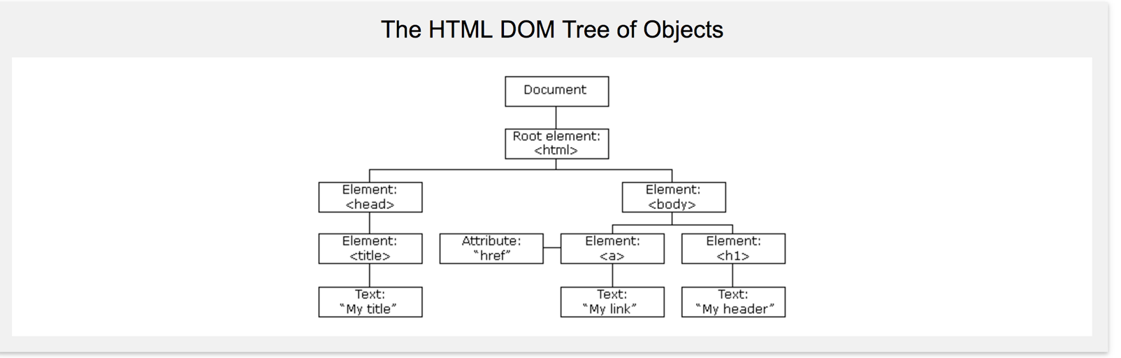

     **c) What are Javascript HTML DOM Methods and properties? Show an example of each one of them.**[**http://www.w3schools.com/js/js_htmldom_methods.asp**](http://www.w3schools.com/js/js_htmldom_methods.asp)

-You can change HTML elements in the page

-You can change attributes in the page

-Change CSS styles in the page

-Remove existing HTML elements

- Add, modify, react and create new ones

**-Property:** Value that you can get or set by changing the content of an HTML element

**-Method:** Action you can do like adding or deleting an HTML document

  **d) What is the Javascript HTML DOM Document Object:**[**http://www.w3schools.com/js/js_htmldom_document.asp**](http://www.w3schools.com/js/js_htmldom_document.asp)

Owner of all other objects in your web page

Represents your web page

If you want to access any of the elements inside an HTML page, you need to start accesing the document.

**e) How can you find HTML Elements with JavaScript?:**[**https://www.w3schools.com/js/js_htmldom_elements.asp**](https://www.w3schools.com/js/js_htmldom_elements.asp)

**Finding HTML elements :**

.getElementById()

.getElementsByTagName

.getElementsByClassName

**Changing HTML elements:**

Element.innerHTML = ‘ ’;

Element.attribute = new value

Element.setAttribute(attribute, value)

Element.style.property = new style

**Adding or deleting elements:**

Document.createElement(element)

Document.removeChild(element)

Document.append(element)

Document.replaceChild(element)

Document.write(text)

     f) How can you change the HTML with JavaScript?:   
   http://www.w3schools.com/js/js_htmldom_html.asp. Do the exercises.

Element.innerHTML = ‘ ’;

Element.attribute = new value

Element.setAttribute(attribute, value)

Element.style.property = new style

     g) How can you change the style of HTML elements with JavaScript?: http://www.w3schools.com/js/js_htmldom_css.asp. Do the exercises.

Document.createElement(element)

Document.removeChild(element)

Document.append(element)

Document.replaceChild(element)

Document.write(text)